ConvertEEG2FM User Guide

On opening ConvertEEG2FM application, this dialog box presents itself. To open the first EEGLAB file for conversion, click on Open file. A standard open file dialog appears; select the .set file to be converted. A few seconds later the dialog will update with the file information (next page).

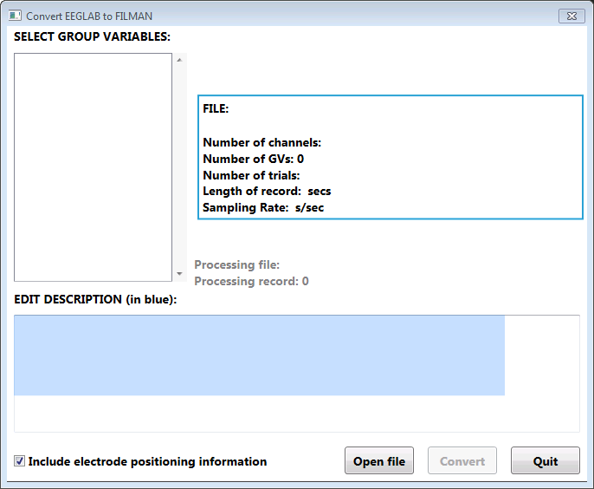

This shows the information for the opened file, including file name, the number of channels remaining in the file, the number of trials in the file, record length and sampling rate. Now select the variable names to be included in the converted file from the list presented. The indicated Number of GVs will reflect the number selected. Then edit the description to be included in the FILMAN file header. Only six lines of 72 characters each, indicated by the blue rectangle for guidance, will be saved. Indicate whether channel location information in the FILMAN header channel names is to be included for later use in FILMAN or FMGraph2.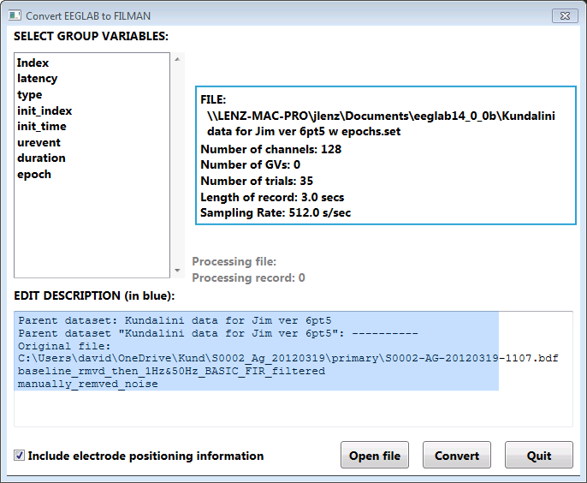

Here is the dialog after selecting the GVs and editing the description to fit in the FILMAN header record. Note that 5 GVs were selected, which results in 7 GVs in the FILMAN records (with added Channel number and Montage GVs). Now select the Convert button to begin the conversion to FILMAN. A dialog will be presented to select location and to name the new file.

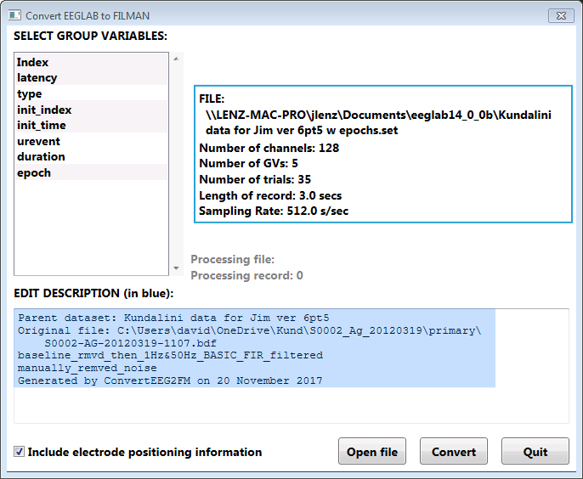

Progress in the conversion is indicated below the File information box. While the conversion is going on, a second dataset may be prepped for conversion by opening a second .set file as shown on the next page.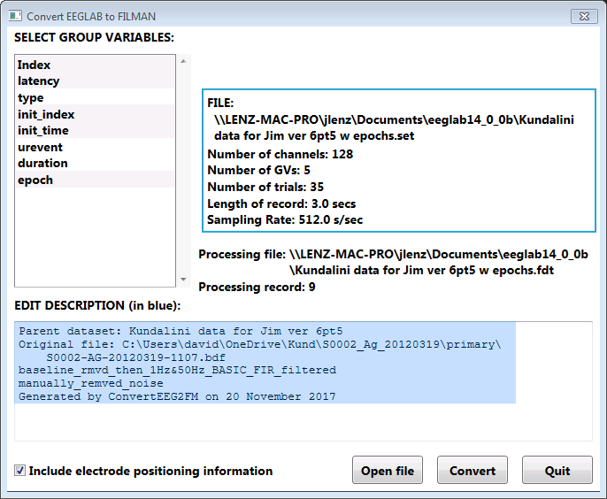

Here we have opened a second file while still converting the 22nd record of the first dataset. The set-up of the second dataset may be performed, but the conversion can’t be started before the first finishes.

